



Creating new module and importing that module to execute for the simple calculation in Python
LAB MANUAL

Disclaimer: The content is curated from online/offline resources and used for educational purpose only
Creating new module and importing that module to execute for the simple calculation in Python
Objective:
- To Implement simple arithmetic operations (addition, subtraction, multiplication, division) in a separate Python file.
- To explore how to import your custom module into another Python script to execute the functions.

Problem Statement:
- Python allows you to organize your code into modules, making it reusable and more manageable. In this task, you will create a Python module that performs simple calculations such as addition, subtraction, multiplication, and division. Then, you will import this module into another Python script to execute these calculations.

Equipment Required:
- Install VS Code - https://code.visualstudio.com/download
- Download Python Installer File - https://www.python.org/downloads/
Prerequisites:
- Basic Computer Skills - Anyone starting to learn computer programming needs basic computer skills.
- Basics of control statements

Procedure:
Task 1: To Create a Python Module for Simple Calculations
Task 2: To Create Another Python Script to Import and Use the Module

Task 1: To Create a Python Module for Simple Calculations
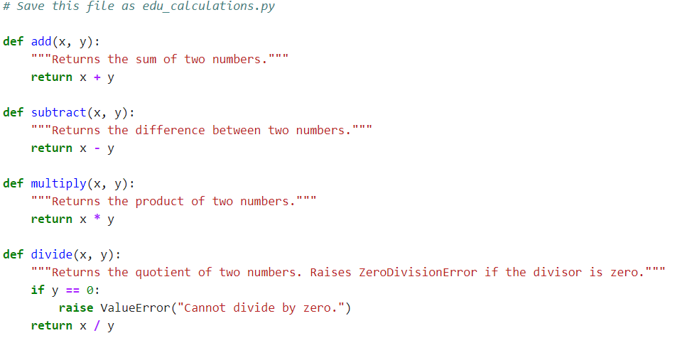

Run: python edu_calculations.py, by excuting this code, we can ensure the error free code.
After that,
Task 2: To Create Another Python Script to Import and Use the Module

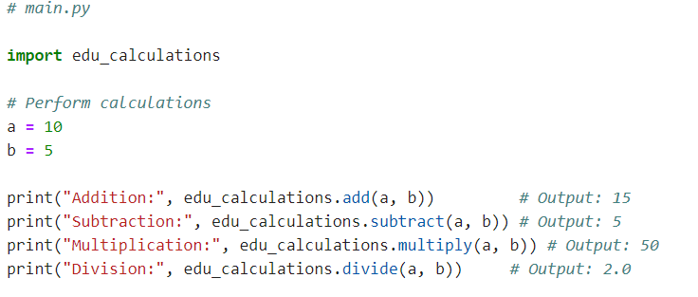
Run: python main.py
Output
